... A MEDICAL EMERGENCY

Call the Medical Service 12

- Specify:
- the exact location,
- why you are calling,
- the state and the number of casualties,
- the circumstances,
- Do not be the first to end the phone call

- Call the nearest first-aider (photos on the notice-boards in the corridors)

- Protect yourself and others to avoid further damage.

- Never move an injured person; wait for help to arrive.

SITE PLAN

… OF A FIRE OR
TECHNICAL ACCIDENT

Call the Reactor control room by dialling 12 or

04 76 20 71 81, or use one of the red telephones (FLS/reactor security)

- Attack the fire using the most appropriate extinguishers

- If the fire starts to spread: evacuate the building, avoiding the lifts.

- Keep low to the ground in smoke-filled areas: the freshest air is at ground level.

… ON HEARING THE SITE OR BUILDING ALARM

If you hear a siren or alarm
… inside a building:
- Proceed calmly to the assembly point for your area, without using the lifts. Remember that the in-building alarms take priority over external alarms.

… modulated in tone, broadcast by sirens outside the building:
- Take cover in the nearest building. Close the doors, windows and other ventilation ducts. Wait for the next instructions.
- If, once inside, you hear the inside siren or verbal instructions to that effect, proceed to the external assembly point, where you will be given instructions on how to evacuate the site.

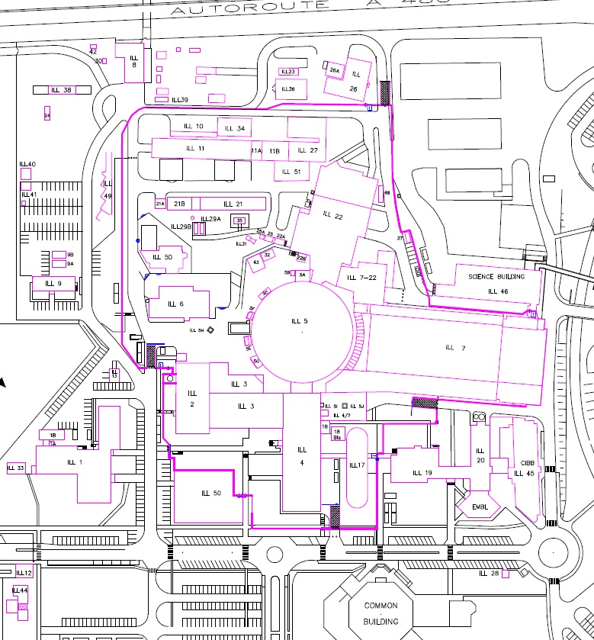

PRI 1 and 2
PRE

EPN Campus entrance
For all questions on: - Conventional safety: contact the Safety Engineers group (73 33, 70 81, 76 74 or 71 67),
- Health physics: contact the SCR (the Service competent for health physics (71 67, 77 04 or 31),
- Health matters, contact the Medical Service (78 71 or 72 18).

- The ILL is specially equipped for people with disabilities

- Key:
External assembly point
Internal assembly points
Medical service (ILL 17)

ACCESS TO AREAS WITH A RISK OF EXPOSURE
TO IONISING RADIATION

Some of the areas within the Institut Laue Langevin may be exposed to ionising radiation (radioactivity) and are therefore health physics classified.

This is indicated by one of the following signs posted at their entrance:

Sign | 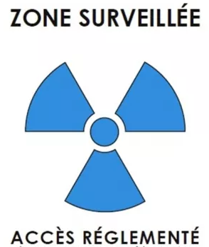 | 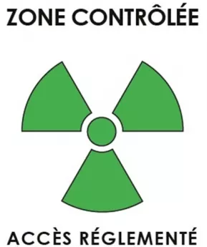 | 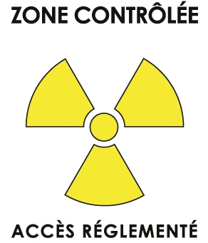 | 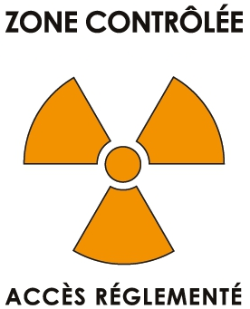 | 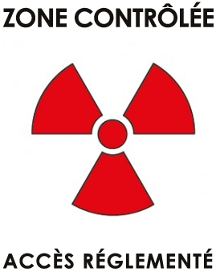
Meaning | BLUE SUPERVISED AREA | GREEN CONTROLLED AREA | YELLOW CONTROLLED AREA | ORANGE CONTROLLED AREA | RED CONTROLLED AREA

Access to these areas is strictly regulated. Note in particular that personal dosimeters must be worn.
If you need to access these areas, contact your ILL correspondent.

Do not forget!

- There is a 30 km/h speed limit on the site.
- Drinking, eating and smoking are forbidden in the laboratories and areas liable to be exposed to ionising radiation.
- The relevant personal protective equipment must be worn (appropriate gloves, eye wear, safety shoes, work clothes…).
- The Medical service and your manager must be informed of any accident occurring at work.
- Ensure that all waste is properly sorted and that no chemical products are to be disposed of in the sinks.
- reduce to the strict minimum the introduction and storage of combustible material in the work areas.
For all questions on: - Conventional safety: contact the Safety Engineers group (73 33, 70 81, 76 74 or 71 67),
- Health physics: contact the Service competent for health physics (71 67, 77 04 or 31),
- Health matters, contact the Medical Service (78 71 or 72 18).
For all questions on: - Conventional safety: contact a Safety engineer (70 81, 76 74 or 71 67),
- Health physics: contact the SCR (the Service competent for health physics (71 67, 77 04 or 31)),
- Health matters, contact the Medical Service (78 71 or 72 18).

